**Software Testing Assignment**

**Module–1(Fundamental)**

* **What is SDLC?**

**SDLC -Software Development Life Cycle imposed on the development of a software product that deﬁnes the process for planning, implementation, testing, documentation, deployment, and ongoing maintenance and support. There are many development models.**

* **What is software testing?**

**Software Testing is a process used to identify the correctness,**

**Completeness, and quality of developed computer software.**

* **What is agile methodology?**

**Agile SDLC model is a combination of iterative and incremental process models with focus on process adaptability and customer satisfaction by rapid delivery of working software products.**

* **What is SRS**

**A software requirements speciﬁcation (SRS) is a complete description of the behaviour of the system to be developed.**

**It includes a set of use cases that describe all of the interactions that the users will have with the software.**

* **What is oops?**

**OOPS is object-oriented programming system.**

* **Write Basic Concepts of oops.**

**Concepts of OOPS:**

* **Object**
* **Class**
* **Encapsulation**
* **Inheritance**
* **Polymorphism**
* **Abstraction**
* **What is an object?**

**Object is an instance of a class. Objects are tangible things, roles, incidents, interactions, speciﬁcations**

* **What is class?**

**Class is a collection of data member (variable) and member function (process, methods) with its behaviour.**

* **What is encapsulation?**

**Encapsulation is data hiding wrapping up data into a single unit. Private your data member and member function.**

* **What is inheritance?**

**Properties of parent class extend into child class.**

**Properties of parent class extend into sub class.**

**Main purpose is reusability, extensibility.**

**There are main 5 types.**

1. **Single**
2. **Multilevel**
3. **Hierarchical**
4. **Multiple - java does not support directly.**
5. **Hybrid - java does not support directly.**

* **What is polymorphism?**

**Polymorphism is the ability to take one name having many forms or multiple forms.**

**There are mainly two types**

1. **Compile time (Method overloading)**
2. **The method name should be the same in same class but its behaviour are different.**

* 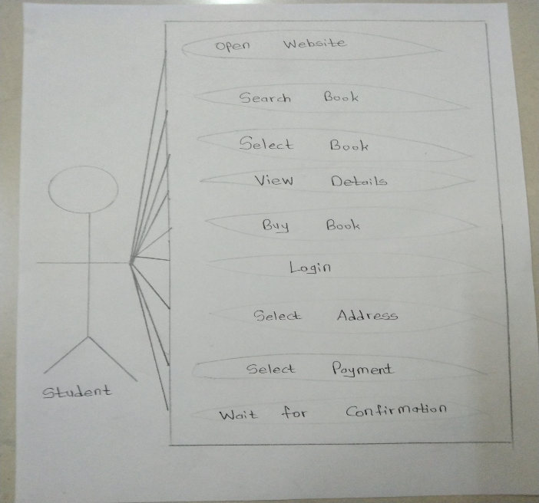**Draw Use case on Online book shopping**
* **Draw Use case on online bill payment system (Paytm)**

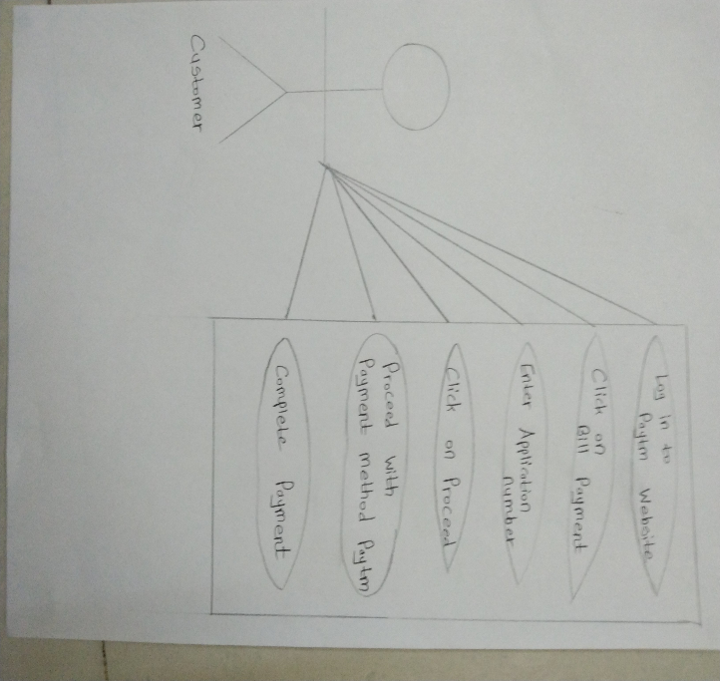

* **Write SDLC phases with a basic introduction.**

**Requirements Collection: Establish customer needs**

**Analysis: Model and specify the requirements “What”**

**Implementation: Construct a solution in software**

**Testing: validate the solution against in-software**

**Maintenance: Repair defects and adapt the solution to the new requirements.**

* **Write phases of spiral model**

**Planning: Determination of objectives, alternatives, and constrains.**

**Risk Analysis: Analysis of alternatives and identification of risk**

**Engineering: Development of “next level” product**

**Customer evaluation: Assessment of the result of engineering**

* **Write agile manifesto principles**

**Agile model believes that every project needs to be handled diﬀerently and the existing methods need to be tailored to best suit the project requirements. In agile the tasks are divided to time boxes (small time frames) to deliver speciﬁc features fora release.**

* **Explain the working methodology of agile model and also write pros and cons.**
  + **Agile Methods break the product into small incremental builds.**
  + **These builds are provided in iterations.**
  + **Each iteration typically lasts from about one to three weeks.**
  + **Every iteration involves cross-functional teams working simultaneously on various areas like planning, requirements analysis, design, coding, unit testing, and acceptance testing.**
  + **At the end of the iteration a working product is displayed to the**
  + **customer and important stakeholders.**
    - **PROS:**
    - **Is a very realistic approach to software development**
    - **Promotes teamwork and cross training?**
    - **Functionality can be developed rapidly and demonstrated.**
    - **Resource requirements are minimum.**
    - **Suitable for ﬁxed or changing requirements**
    - **Delivers early-partial working solutions.**
    - **Good model for environments that change steadily.**
* **Minimal rules, and documentation are easily employed.**
* **Enables concurrent development and delivery within an overall planned context**
* **Little or no planning required Easy to manage Gives ﬂexibility to developer**
  + - **CONS:**
* **Not suitable for handling complex dependencies.**
* **More risk of sustainability, maintainability and extensibility.**
* **An overall plan, an agile leader and agile PM practice is a must without which it will not work.**
* **Strict delivery management dictates the scope, functionality to be delivered, and adjustments to meet the deadlines.**
* **Depends heavily on customer interaction, so if customer is not clear, team can be driven in the wrong direction.**
* **There is very high individual dependency, since there is minimum documentation generated.**
* **Transfer of technology to new team members may be quite challenging due to lack of documentation use – case**
* 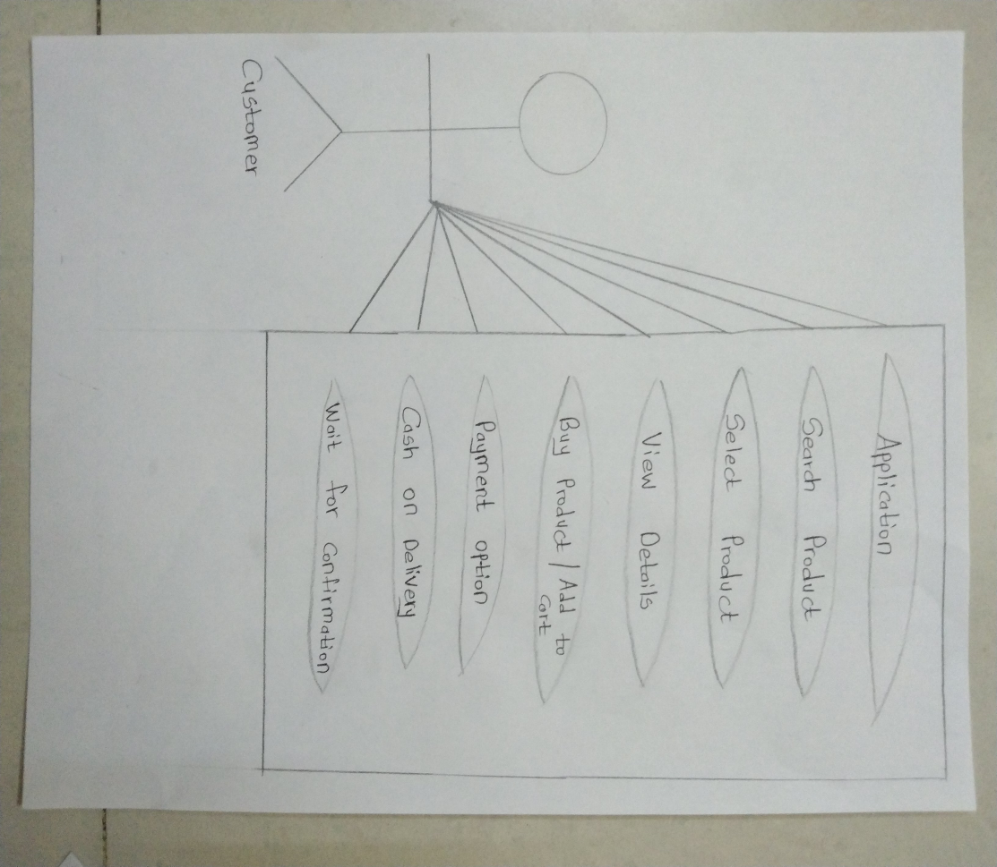**Draw use case on Online shopping product using COD.**
* 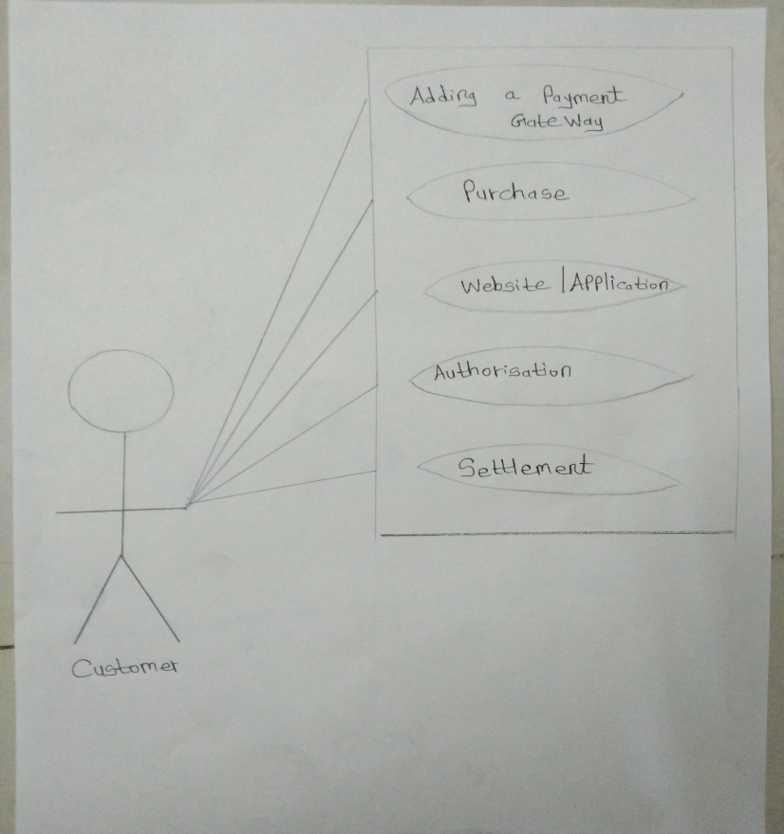**Draw use case on Online shopping product using payment gateway**